1) γ_{p}
γ_{p} is a speed factor used to to show what extent the interconnects are faster than the base line slow interconnects. Therefore, interconnects are γ_{p} times faster than baseline slow interconnects or
T_{e [fast]} = T_{e [slow]} / γ_{p} .

Baseline T_{e} we used is real world recorded EPR generation time and it is 4ms and according to Latest reports, EPR time can be reduced to 10 micro sec. so, we can scale the value of γ_{p} from 1 to 400.

2)γ_{a}
γ_{a} = BW_{fast} / BW_{slow}

T_{e} = 1/Bw γ_{a} = [ 1/ T_{e [fast]} ]/[ 1/T_{e [slow]} ]
γ_{a} = T_{e [slow]} / T_{e[fast]}
γ_{a =} γ_{p}

Bandwidth vs T_{e} Plots
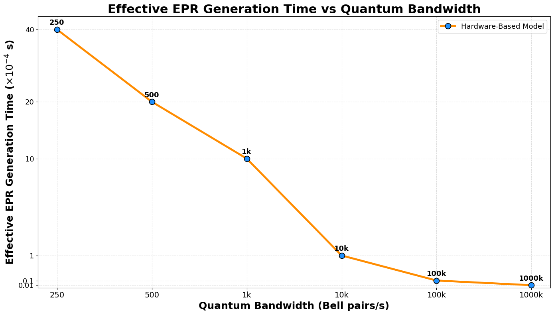

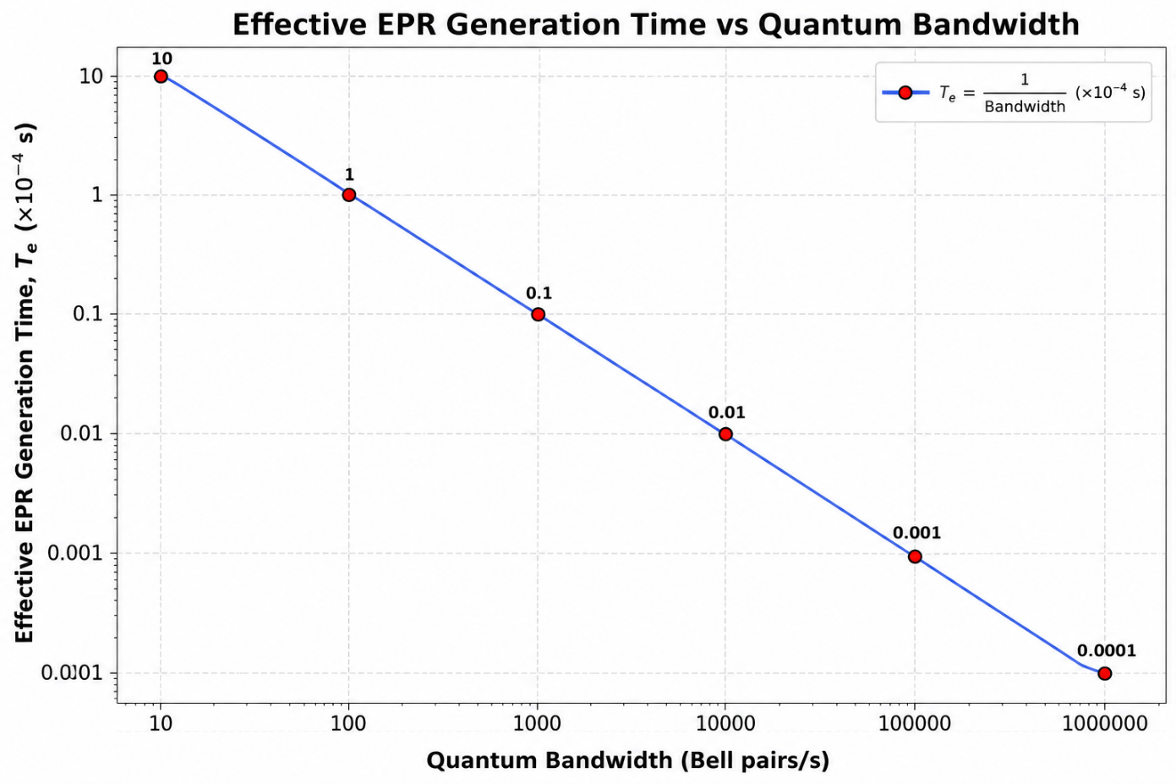

Observations:
From bandwidth
10 to 100, decrease in t = 9 * 10⁻⁴ sec
100 to 1000, decrese in t = 0.9 * 10⁻⁴ sec
10³ to 10⁴ , decrease in t = 0.09 * 10⁻⁴ sec ~~ 9 * 10⁻⁶ sec
10⁴ to 10⁵ , decrease in t = 0.009 * 10⁻⁴ sec ~~ 9 * 10⁻⁷ sec.
10⁵ to 10^{6,} decrease in t = 9* 10⁻⁸ sec T_{e} = 1 micro sec.

Why we are stopping between 10⁵ and 10⁶ ?
The reason is, recorded gate times are between 10 micro seconds to 1 milli second. And we are improving interconnect speed because they are working at low speeds than gates. If they are operated at similar speeds, our motive is satisfied.[ we need to consider hardware constraints and availability also. ].

